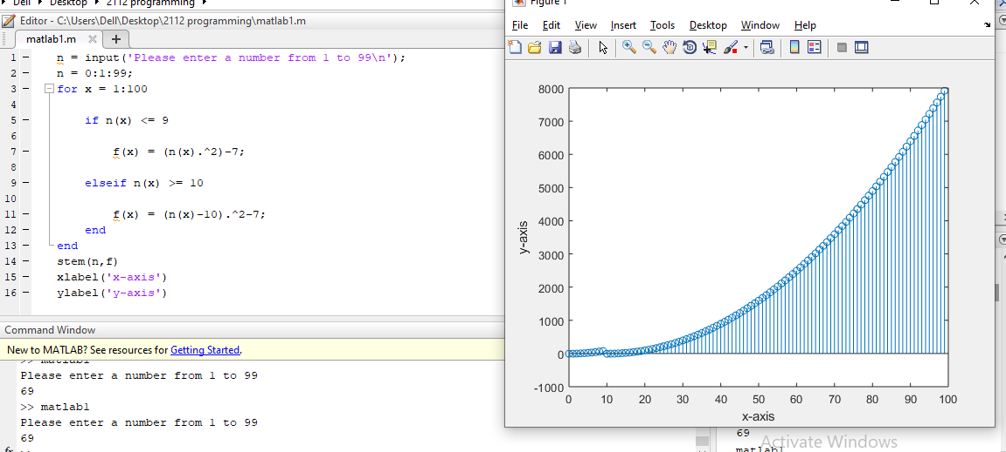

The graph of the function starts with an initial value of 0 in the x-axis and -7 in the y-axis and continually increases with respect to the first condition of the function.

When it reaches the value of 10 in the x-axis, the graph resets back to the initial values of the x and y-axes due to the second condition. From that point, the graph continues to increase exponentially it reaches the values of 100 and 7914 of the x-axis and y-axis, respectively.